Third Conference of the States Parties
to the UN Convention against Corruption
Doha, Qatar
9 – 13 November 2009
Agenda
CSO Forum
11 November 2009
9:00 – 18:00
AL MAJLIS CONFERENCE ROOM

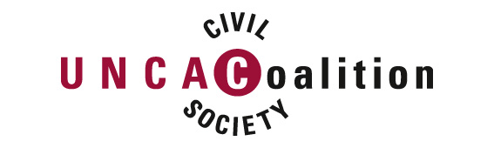

Time | Name of the Session / Speakers
9:00 – 9:45 | Session 1: Role of civil society & transparency in the fight against corruption: UNCAC Article 13
 | Chair: Huguette Labelle, Transparency International
 | Article 19, Toby Mendel (TBC), International standards on access to information
 | Iftekhar Zaman, Transparency International- Bangladesh
 | Gregory Ngbwa Mintsa,( Gabon)
9:45 - 11:20 | Session 2: CSO participation and transparency in monitoring UNCAC
 | Chair: Christiaan Poortman, Transparency International
 | Fritz Heimann, Transparency International (USA)
 | Slagjana Taseva, Transparency Zero Corruption, TI Macedonia
 | Manzoor Hasan, BRAC Institute on Governance (Bangladesh)
 | John Williams, GOPAC (tbc) (Canada)
11:20 – 12:30 | Session 3: CSO participation and transparency in the UNCAC pilot review programme
 | Chair: Abi Akinyemi, Tearfund
 | Mr. Marcel van den Bogaard, Ministry of Foreign Affairs, Government of the Netherlands
 | Adele Poskitt, Christian Aid (UK)
 | Dr Vincent Kihiyo, Government of Tanzania
12:00 – 13:00 | Daily press briefing
13:00 – 14:00 | Lunch
14:00 - 15:30 | Session 4: UNCAC preventive measures for public and private sector integrity
 | Chair Jermyn Brooks, Transparency International (UK)
 | Bruna de Carvalho, Associacao Contas Abertas
 | Magnus Ohman, IFES (USA)
 | Tinatin Ninua, Transparency International (Georgia)
 | Santosh Kumar Patra, Institute for Applied Sociology (India)
15:30 – 16:40 | Session 5: Anti-money laundering, asset recovery and tax havens
 | Chair: Maud Perdriel-Vaissière, Sherpa (France)
 | Robert Palmer, Global Witness (UK)
 | Job Ogonda, TI (Kenya)
 | Jack Blum, US-Attorney and Government Advisor, Chair, Tax Justice Network USA
16:40 – 18:00 | Session 6: The role of corruption in trafficking in persons
 | Chair: Julie Kvammen, United Nations Office on Drugs and Crime (UNODC)
 | Londa Esadze, TraCCC (Georgia)
 | Klara Skrivankova, Anti-Slavery International
 | Lilian Ekeanyanwu, Government of Nigeria

