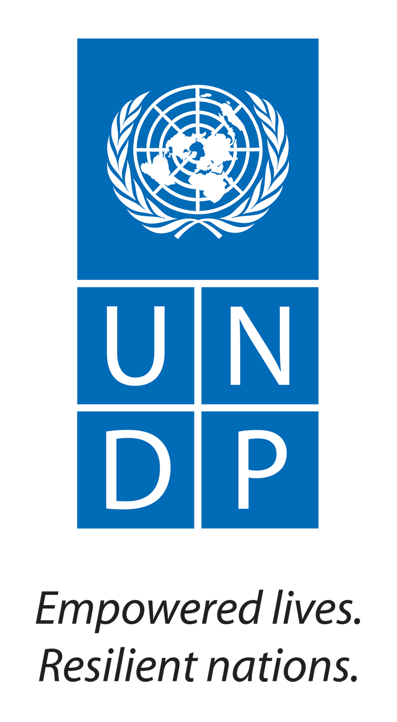

UNITED NATIONS DEVELOPMENT PROGRAMME
VACANCY ANNOUNCEMENT NO. UNDP/SC/2013/01

Date of Issue: 10 January 2013
Closing Date: 24 January 2013

Post Title : Communications Officer

Organization : United Nations Office on Drugs and Crime (UNODC)

Duty Station : New Delhi
Duration : One Year (extendable)

Type of Contract : Service Contract (taxable)

Band : SB-4
Remuneration package starts at Rs. 81,197/- per month (taxable). UNDP also offers additional benefits which include medical insurance coverage and limited pension reimbursement for contract holder and encourages work life balance.

UNDP strives to have a workforce which reflects diversity and gender balance, and applies an equal opportunities approach. UNDP does not solicit or screen for information in respect of HIV or AIDS status. All selection is on merit.

Background

Since 2009, UNODC’s Regional Office for South Asia (ROSA) is implementing focused communications and advocacy activities with four major elements: (a) an attractive, issue-based website with weekly updates in form of stories and interviews (b) organization of selected public events, (c) selected production of publications on UNODC’s work and their dissemination and (d) interaction with media on UNODC issues in a structured and selected way.

UNODC would like to hire the services of a Communications Officer with excellent communication skills, both written and verbal, a solid understanding of the domain of UNODC’s mandate and the sensitivity of its issues, an ability to work with and relate to a diverse set of clients, and excellent visualization skills. The chief responsibility of this position is to effectively communicate the UNODC’s work online and organize the UNODC representative’s media contacts.

Duties and Responsibilities

Under the overall supervision and guidance of the Representative, the Communications Officer will be responsible for:

- Maintain and update regularly the UNODC ROSA website, including the production of one web story per week and the linking of news and other relevant information
- Produce one monthly newsletter on South Asia
- Propose, organize and support the production of UNODC inputs to as well as of publications, including their dissemination
- Maintain a database with the main UNODC contacts in the region for the dissemination of UNODC publications, including media contact
- Engage proactively with the Communications Groups of the UNCTs in the region
- Organize media activities for the Representative
- Maintain a repository of all communications-related activities on UNODC ROSA
- Review the communication activities, seeks their improvement involving UNODC staff and external audience
- Perform other activities as requested.

Competencies

- Professionalism: Shows pride in work and in achievements. Demonstrates professional competence and mastery of subject matter. Is conscientious and efficient in meeting commitments, observing deadlines and achieving results. Is motivated by professional rather than personal concerns. Shows persistence when faced with difficult problems or challenges. Remains calm in stressful situations.
- Communication: Speaks and writes clearly and effectively. Listens to others, correctly interprets messages from others and responds appropriately. Asks questions to clarify, and exhibits interest in having two-way communication. Tailors language, tone, style and format to match audience. Demonstrates openness in sharing information and keeping people informed.
- Teamwork: Works collaboratively with colleagues to achieve organizational goals. Solicits input by genuinely valuing others’ ideas and expertise; is willing to learn from others. Places team agenda before personal agenda. Supports and acts in accordance with final group decision, even when such decisions may not entirely reflect own position. Shares credit for team accomplishments and accepts joint responsibility for team shortcomings.
- Planning & Organizing: Develops clear goals that are consistent with agreed strategies. Identifies priority activities and assignments; adjusts priorities as required. Allocates appropriate amount of time and resources for completing work. Foresees risks and allows for contingencies when planning. Monitors and

Educational Qualifications

- Master's Degree and minimum 5 years of relevant professional experience, or equivalent, in a similar profile.

Experience and skills

- Experience in writing and editing skills for the Web and on strategic and qualitative issues
- Proven writing and editing skills in English, with an ability to convey complex ideas in a clear and direct style
- Excellent creative thinking and content development skills
- Strong diplomatic and interpersonal skills
- Demonstrated client orientation
- Ability to work under stress and multiple tasks under tight deadlines
- Skilled at design, including website designing and online editing tools viz. flash, multimedia etc.
- Ability to make digital content web friendly viz. video capture, editing and streaming
- Skilled at using Content Management Systems
- Proven ability of Search engine optimization

Languages

- Excellent spoken and written English is required
- Knowledge of the local language is desirable.

Please apply online by visiting www.in.undp.org (Careers)

