9 Measuring the Influence of Statistical Counting Rules on Cross-National Differences in Recorded Crime

Marcelo F. Aebi

Combining data on offences known to the police and metadata on the rules applied by European countries to produce their criminal statistics, this article shows how the counting rules used to collect data for police statistics in each country affect the outcome of such statistics and constitute one of the main explanations of cross-national differences in levels of recorded crime. In particular, a comparison of crime rates shows that the group of countries that records offences when they are reported to the police presents higher crime rates than the group of countries that records offences when the police have completed the investigation.

9.1 Introduction

Research on cross-national comparisons of recorded crime rates usually includes a statement like the following: “Crime rates from country to country are difficult to compare because of differences in criminal justice systems, in definitions of crime, in crime reporting practices and recordkeeping” (Kalish 1988). Systematizing the difficulties inherent to those comparisons, von Hofer (2000) identifies three types of factors that determine the outcome of crime statistics: statistical factors, legal factors and substantive factors. These factors affect the national crime statistics of each country in a different way, hence complicating cross-national comparisons.
Substantive factors refer to the propensity to report offences by the population of each country, to the propensity to record offences by the police or other recording authorities, and to the actual crime levels. Legal factors refer to the influence of the legal definitions of offences adopted in each country and to the characteristics of the legal process such as the delays for prescription or the possibility for the prosecuting authorities of bringing to court personal offences − such as rape − on their own initiative. From that point of view, the use of the legality principle or the opportunity (or expediency) principle by the prosecuting authorities has a strong influence on the number of offences dealt with by courts.
Finally, statistical factors refer to the way in which crime statistics are elaborated. In that context we define the statistical counting rules as the rules applied in each country to count the offences and the offenders that will be included in crime statistics. Such rules vary from country to country, hence introducing differences in recorded crime rates that do not reflect actual differences in the levels of crime.
Using data on offences known to the police from the Ninth United Nations Survey of Crime Trends and Operations of Criminal Justice Systems and metadata on statistical counting rules taken from the European Sourcebook of Crime and Criminal Justice Statistics 2006 (Aebi et al. 2006; referred to in the rest of this article as European Sourcebook 2006), this paper analyzes the influence of statistical counting rules on cross-national comparisons of recorded crime in European countries.

9.2 Statistical counting rules in forty European countries

Since the publication of the first European Sourcebook in 1999, the group of experts in charge of it has paid special attention to the way in which data are collected for police statistics in each country. Thus, each edition contains one table summarizing the answers given by the countries to the following questions:
- Are there written rules regulating the way in which data are recorded?
- When are the data collected for the statistics?
- What is the counting unit used in the statistics?
- Is a principal offence rule applied?
- How are multiple offences counted? and
- How is an offence committed by more than one person counted?

In this article, we will use the answers included in the latest edition of the European Sourcebook (2006, 76-77). They refer to the statistical counting rules applied in 2003 and they are illustrated in Figures 9.1 to 9.6. Latvia, Norway and Turkey did not fill the questionnaire for the third edition of the European Sourcebook (2006) and therefore the answers are taken from the second edition of it (Killias et al. 2003, 74-75; referred to in the rest of this article as European Sourcebook 2003) and relate to 1999.

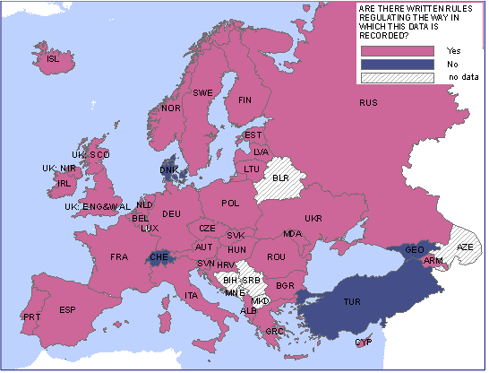
Figure 9.1. Are there written rules regulating the way in which data are recorded?

As can be seen in Figure 9.1, with the exceptions of Denmark, Georgia and Turkey − where there are no written rules − as well as Switzerland − where there are no rules at the federal level, but most cantons have such rules −, the rest of the European countries do have written rules regulating the way in which data are recorded for statistics. Indeed, the presence of such rules guarantees some level of homogeneity in the recording practices of different police officers or different police forces within the same country.
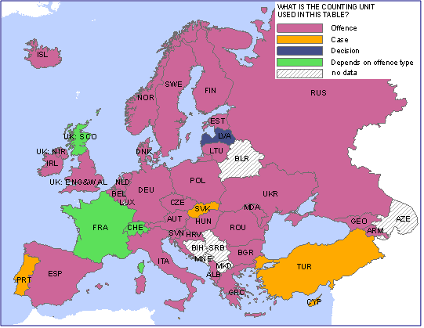
Figure 9.2. What is the counting unit used in the statistics?

Figure 9.2 shows that, usually, the counting unit used in European police statistics is the offence. Nevertheless, in Cyprus, Luxembourg, Malta, Portugal, Slovakia and Turkey the counting unit is the case, and in Latvia it is the decision. Finally, in France, Switzerland and Scotland, the counting unit varies according to the type of offence recorded. Thus, in Scotland, as far as offences against the person are concerned, one crime is counted for each victim; while for offences of dishonesty (i.e. theft acts) and robbery, one crime is counted per incident, regardless of the number of victims.
The difficulty comes from the fact that, according to the counting unit used in the statistics, figures will differ from one country to another. For example, a case may include several offences, or a decision may refer to more than one offence.
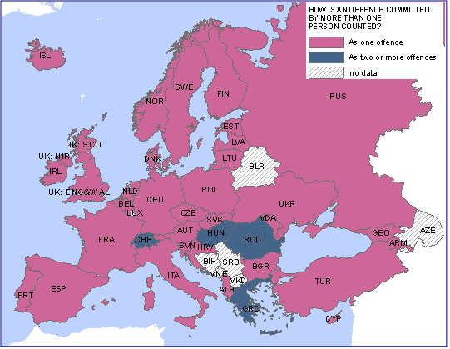
Figure 9.3. How is an offence committed by more than one person counted?

As it is shown in Figure 9.3, when more than one person commits an offence − for example, when a gang of ten members robs a bank − most countries count one offence, but Greece, Hungary, Romania, and Switzerland count one offence for each offender. In addition, Sweden counts one offence for each offender in cases of rape and drug offences, and France does the same for some offences.
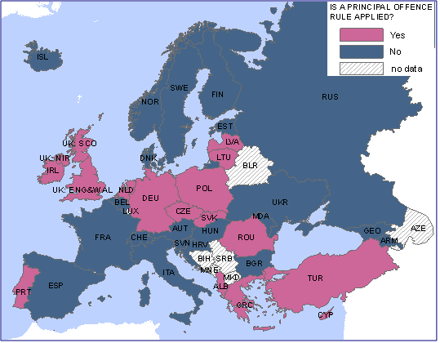
Figure 9.4. Is a principal offence rule applied?

Another source of artificial differences in the levels of recorded crime is the way in which simultaneous offences are recorded. In countries using a principal offence rule, only the most serious offence is recorded, while in countries without such a rule, each offence is recorded independently. For example, if in the course of theft an offender also causes damage to the property and kills one person, police statistics of countries applying a principal offence rule will show only one offence (i.e. homicide), while in countries where there is no such rule, each offence (homicide, damage to property and theft) will appear separately. As a consequence, by the end of the year − when thousands of offences have been recorded − the total number of offences will be quite different in a country that applies the principal offence rule and in a country that does not apply it. As can be seen in Figure 9.4, eighteen European countries apply a principal offence rule and twenty-one do not apply such a rule.
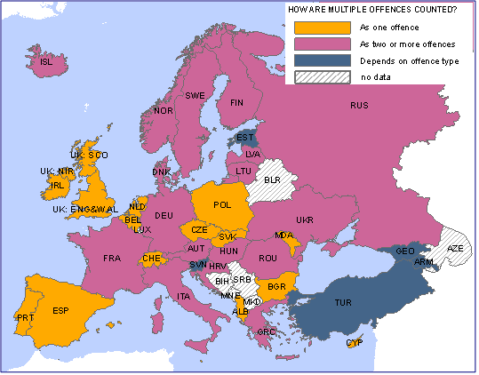
Figure 9.5. How are multiple offences counted?

A similar problem is raised by multiple offences, i.e. by offences of the same kind, which are often called serial offences. For example, if a woman reports to the police that her husband has beaten her ten times during the last six months, it is crucial to know whether the police will record one or ten offences. Figure 9.5 shows that, in such cases, eighteen European countries count only one offence, seventeen count two or more offences, and in the remaining five countries (Armenia, Estonia, Georgia, Slovenia and Turkey) the rule depends on the type of offence. Moreover, in France, Germany and Finland there are some exceptions to the general rule that states that multiple offences should be counted as two or more offences. Thus, in Germany, multiple offences against the same victim or without a victim are counted as one offence (while multiple offences against different victims are counted as two or more offences). In Finland, multiple drug offences and fraudulent payments with credit cards are counted as one offence. Finally, in France, there is a link between multiple offences and the counting unit used for the statistics; thus, when the counting unit is the case (e.g. drug trafficking), multiple offences will be counted as one offence.
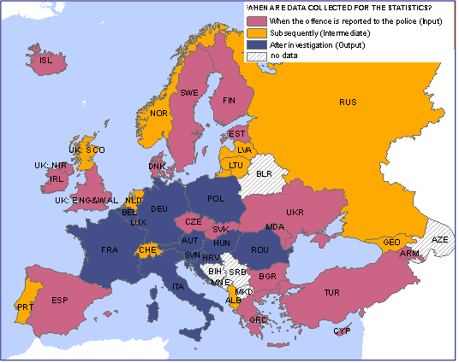
Figure 9.6. When are the data collected for the statistics?

Last but not least, according to the moment when data are collected for the statistics, countries can be classified in three different groups: those with input statistics, those with output statistics and those with intermediate statistics. In countries using input statistics, data are recorded for statistical purposes when the offence is reported to the police (or when police officers observe or discover an offence). In contrast, in countries using output statistics, data are recorded when the police have completed the investigation. In between these extremes, some countries record data at an intermediate stage of the process, i.e. at some point in time between the input and the output. Unfortunately, it is not possible to know in which countries that moment in time is closer to the input and in which ones it is closer to the output.
Knowing that the number of offences registered by official measures of crime decreases as the criminal process advances (Sellin 1951; President’s Commission 1967), one should expect that, all other things being equal − including, for example, the definition of the offences, the actual level of crime, the propensity to report and to record offences as well as all other statistical, legal and substantive factors −, countries using input statistics will present higher crime rates than countries using output statistics.
For example, in countries with input statistics, when a person reports a theft to the police, the offence is automatically included in police statistics; in contrast, in countries with output statistics, the report is received but the offence is not included in the statistics until the police investigation is complete. Thus, the offence will not appear in police statistics if the investigation reveals that it never happened. Moreover, if the police discover that it was a case of false reporting, this new offence will appear both in countries with input and in countries with output statistics. As a result, the first ones will record two offences in their statistics but the second ones will only record one.
Indeed, this problem is related to the validity and reliability of police statistics. In countries with input statistics, the police officers arriving at the scene of a crime or receiving a report from a victim usually do not have enough information about the circumstances of the offence, and this may lead them to classify it inadequately. For example, the evidence collected during the investigation may show that what seemed to be an attempted homicide was in fact a case of aggravated assault; therefore, countries using output statistics will record one aggravated assault in their statistics, but countries using input statistics will record one attempted homicide.
Output statistics could thus be considered as more reliable than input statistics, but at the same time they are less valid than the former because some offences may disappear from the statistics only because the police were unable to find relevant evidence. As can be seen in Figure 9.6, twenty European countries use input statistics, ten countries use intermediate statistics and ten countries use output statistics.
To complicate the picture, all the statistical factors mentioned presented in Figures 9.1 to 9.6 combine themselves in each country. In that context, all other things being equal, one should expect that countries with input statistics, using offences as counting units, not applying a principal offence rule, counting multiple offences as two or more offences, and offences committed by more than one person as two or more offences, would present the highest rates of recorded crime. But that hypothesis cannot be tested just by comparing countries with input vs. countries with output statistics because we cannot control all legal and substantial factors − i.e. all other things − in order to be sure that the differences in recorded crimes are only due to statistical factors. In particular, as we do not know the actual levels of crime in each country, we cannot simulate a situation where these levels are identical across countries. This is also the reason why, at least for the moment, it is impossible to assign a weight to each statistical factor and produce a figure that would take all these factors into account. Indeed, such a procedure would require knowing − for each and every country and each and every type of offence − the “real” number of offences registered at the beginning (input) and at the end of the process (output) as well as the breakdown of all these offences according to the factors mentioned before (i.e. how many of these offences were multiple offences, how many were committed by more than one person, etc.).
Apart from that, an analysis of the answers given to the six questions on counting rules shows twenty-six different combinations in the forty countries studied. Each one of these combinations includes a maximum of four countries (i.e. countries that gave exactly the same answer to all the questions) but the general rule is to have combinations that include only one or two countries. It is thus impossible to take all the rules into account in order to create different groups of countries and compare their crime rates.
At the same time, the influence of each statistical factor is not identical. For example, the way in which multiple offences are counted affects only multiple offences, and the use of a principal offence rule affects only cases where more than one offence has been committed. The only factor that affects the way in which each offence is recorded is the moment when the data are collected for statistics, and it is the one that will be used in the rest of this article.

9.3 Crime rates according to statistical counting rules in thirty-five European countries

As we have seen before, according to the moment when data are collected for statistics, countries can be divided in three groups. The first one includes countries using input statistics, the second one includes countries using intermediate statistics, and the last one includes countries using output statistics. In this section we will compare the crime rates of each of these groups. Logically, our main hypothesis is that the group of countries using input statistics will present higher rates than the group of countries using output statistics. Apart from that, countries using intermediate statistics should also occupy a halfway position.
In order to increase the validity of our analysis we have excluded countries with a population of less than one million inhabitants (Cyprus, Iceland, Luxembourg and Malta) because their rates are extremely instable, as well as Belgium whose data did not seem reliable because major changes in police recording practices were introduced between 2000 and 2003.
Once the groups were created, we have calculated the average number of different offences − total recorded crimes, completed intentional homicides, attempted intentional homicides, non-intentional homicides, major assaults, assaults, rapes, robberies, major thefts, thefts, automobile thefts, burglaries, and kidnappings − per 100,000 population recorded in 2003 in each group according to the Ninth United Nations Survey of Crime Trends and Operations of Criminal Justice Systems. By making that calculation we are placing our analysis at a macro-level because we are comparing groups of countries instead of countries individually. This is because the crime rate of a particular country is explained by a combination of statistical, legal and substantial factors. For example, an extremely high rate for an offence − such as the rates for completed intentional homicide in some Eastern European countries − cannot be explained by only one statistical factor. For the same reason, we have chosen offences whose definitions should be similar across European countries, although we are fully aware that perfect correspondence between the definitions applied in thirty-five countries is impossible. Finally, we have standardized the figures using the output for each offence as index (=100). The results of the comparison between countries with input statistics and countries with output statistics are presented in Figure 9.7.
Figure 9.7 shows that countries using input statistics present almost systematically higher crime rates than countries using output statistics. The only exception are theft offences where the very low figures for Armenia and Turkey (respectively 88 and 104 thefts per 100,000 population) clearly affect the average for the whole cluster of countries with input statistics (1,611 thefts per 100,000 population). Thus, our main hypothesis is confirmed by this analysis.

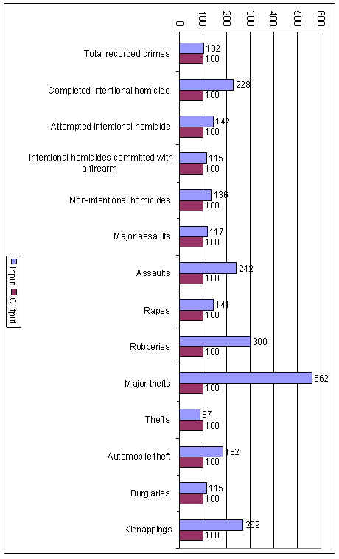
Figure 9.7. Indexed average number of offences per 100,000 population known to the police in 2003 in 35 European countries grouped according to their statistical counting rules: countries with input statistics and countries with output statistics (Output = 100)

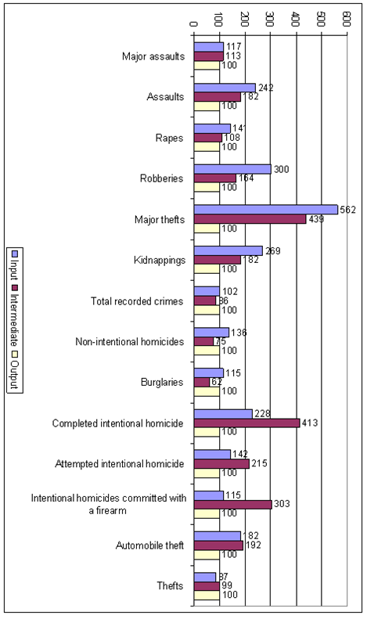
Figure 9.8. Indexed average number of offences per 100,000 population known to the police in 2003 in 35 European countries grouped according to their statistical counting rules: countries with input, intermediate and output statistics (Output = 100)

In Figure 9.8 we have added to the analysis the group of countries using intermediate statistics. It can be seen that, in six offences out of fourteen, our hypothesis is confirmed because the group of countries with input statistics has higher rates than the one with intermediate statistics and the latter has higher rates than the group of countries with output statistics. Apart from that, in three cases (total recorded crimes, non-intentional homicides and burglaries), the group of countries with input statistics has higher rates than the one with intermediate statistics but the latter has lower rates than the group of countries with output statistics. Finally, in five cases, the group with intermediate statistics presents either higher rates than the other two groups (this pattern applies to the three types of intentional homicide and automobile theft), or a rate that is higher than the one of the group of countries with input statistics and almost identical to the one of the group of countries with output statistics (this pattern applies to theft).
Thus, in eight cases out of fourteen, the relationship between these three types of statistics is not as linear at it seems from a theoretical point of view. Indeed, as we have mentioned before, intermediate statistics pose the problem that, with the information currently available, it is impossible to assess the exact moment of the process − between input and output − when data are collected in each country. For example, if in the majority of these countries data were recorded for statistics at a moment in time that is close to the input, it would be logical to have more or less similar crime rates in the group of countries with input statistics and in the group of countries with intermediate statistics; on the contrary, if data were recorded for the statistics at a moment in time that is closer to the output, the rates of the groups of countries with intermediate and with output statistics should be similar.
Unfortunately, with the information available to date it is impossible to go deeply into this matter. However, we can point out that usually the high rates of the group of countries with intermediate statistics are explained by the presence of one or more outliers.
9.4 Discussion

In sum, our analysis generally supports the hypothesis suggesting that the statistical counting rules regarding the moment when data are collected for the statistics play a major role in the explanation of the crime rates registered in each country. Of course, this does not prove that the differences in recorded crime are due to that factor. As we have said before, cross-national differences in recorded crime are due to a combination of statistical, legal and substantial factors. In that context, one cannot exclude that the explanation of the pattern shown in Figures 9.7 and 9.8 is that countries with output statistics are the ones where less offences are effectively committed, but even in that case the difference between these countries and those with intermediate or output statistics would probably be inflated because of the counting rules applied.
Finally, Figure 9.7 suggests that the influence of the counting rules varies according to the type of offence. In fact, while for the total number of offences, the group of countries with input statistics presents rates that are only 2% higher than the ones of the group of countries with output statistics, the percentage rises, for example, to 462% for major thefts, 200% for robbery, 142% for assaults, and 128% for completed intentional homicide. The problem comes from the fact that we do not know precisely which part of that percentage is due to the statistical counting rules applied. Nevertheless, one could suppose that it would be less important in cases such as completed intentional homicide, which is not very common, is clearly defined and verifiable − by the presence of a dead body −, and whose clearance rate is high. Unfortunately − from a methodological point of view −, most offences do not present that profile and, therefore, their rates are probably more influenced by the statistical counting rules applied in each country.

9.5 Conclusion

By comparing the crime rates of European countries according to their counting rules we have seen that the group of countries that registers offences when they are reported to the police (input statistics) presents higher crime rates than the group of countries that registers offences after investigation (output statistics). At the same time, the group of countries that registers offences somewhere between these two points in time occupies an intermediate position and usually, but not always, shows lower crime rates than the group of countries with input statistics and higher crime rates than the group of countries with output statistics.
Therefore we can conclude that European crime rates seem to follow the following pattern: Countries using input statistics reveal higher crime rates than countries using intermediate statistics, and countries using intermediate statistics show higher crime rates than countries using output statistics (see Figure 9.9). This pattern reflects the structure of the criminal justice process, which has often been compared to a funnel (President’s Commission 1967). As we have pointed out before, this in an application of the general principle stating that the number of offences registered by official measures of crime decreases as the criminal process advances (Sellin 1951). Of course, that principle is well known by criminologists, but to our knowledge this is the first research that corroborates empirically its application to cross-national comparisons of recorded crime.

Number of offences recorded in
countries with input statistics
Number of offences recorded in
countries with intermediate statistics
Number of offences recorded in countries with output statistics
Figure 9.9. Statistical counting rules and their influence on the volume of recorded crime

Although our analysis does not prove that cross-national differences in recorded crime are due to the statistical counting rules used in each country, it strongly suggests that these rules play a major role in the explanation of those differences. Moreover, a similar analysis (Aebi 2008) based on data and metadata taken from the second edition of the European Sourcebook (2003) and covering the years 1995 to 2000, confirms the results find here.
As a matter of fact, our findings are not encouraging for researchers engaged in comparative criminology. In this respect, we can imagine a few different ways of dealing with the fact that crime statistics are social constructs, and that each society has its own special way of constructing them. The first one, and the most radical, would simply be to avoid making cross-national comparisons on the basis of crime statistics. In that context, victimization surveys and self-reported delinquency studies conducted with the same questionnaire and the same methodology constitute alternative measures of crime that can be used for such comparisons. A second possibility would be to combine different crime measures. For example, data from victimization surveys, police, conviction, and correctional statistics can be combined through the computation of a series of indexes for each country which, in turn, can be compared across countries (Farrington et al. 2004), or national crime statistics can be combined with victimization surveys by weighting data according to the percentage of offences reported to the police (Aebi et al. 2002), or different crime measures can be combined in an index as the one developed by HEUNI (Aromaa and Joutsen 2003). Nevertheless, the validity of such kind of indexes has not been established yet. In particular, the combination of collections of international crime statistics such as the European Sourcebook, Interpol’s International Crime Statistics or the United Nations Survey on Crime Trends and Criminal Justice Systems presents the problem that all these collections are based on the same national crime statistics, which explains why their crime rates are usually correlated (see the correlations found by Bennett and Lynch 1990, and by Howard and Smith 2003). However, the process of data validation introduced in the European Sourcebook (2006, 18-20) has improved the quality of the data included in that collection and explains why the correlations are not perfect (Aebi et al. 2002). A third alternative would be to restrict the use of crime statistics to comparisons of crime trends only, although in this case the researcher must check for eventual modifications of the counting rules applied during the period studied (Aebi 2004; von Hofer 2000; Killias and Aebi 2000). The fourth one would be to restrict comparisons to countries applying similar statistical counting rules; but taking into account that the similarity must apply to all rules and not only to the one regarding the moment when data are collected for statistics, because even among countries collecting statistics at the same time there are remarkable differences in crime rates that cannot be explained by substantial factors only. The fifth possibility would be to weight crime rates according to the statistical counting rules of each country, but this is not yet feasible because we still do not know the exact percentage of the crime rate that is explained by the statistical counting rules. The real solution would be to introduce more detailed crime statistics − such as the ones used in Sweden − in every country. Until that moment arrives, our analysis suggests that any cross-national comparison of recorded crime rates should pay special attention to the issue of the statistical counting rules applied in each country.

References

Aebi, Marcelo F. (2004). Crime Trends in Europe from 1990 to 2000. In Aromaa, Kauko and Sami Nevala (eds.): Crime and Crime Control in an Integrating Europe: Plenary presentations held at the Third Annual Conference of the European Society of Criminology - Helsinki 2003. Publication Series No. 44. Helsinki: HEUNI, 39-60. Also available online at: http://www.heuni.fi/uploads/ob35f37b1qqdnk(1).pdf
Aebi, Marcelo F. (2008). Temas de Criminología. Madrid: Dykinson.
Aebi, Marcelo F., Kauko Aromaa, Bruno Aubusson de Cavarlay, Gordon Barclay, Beata Gruszczynska, Hanns von Hofer, Vasilika Hysi, Jörg-Martin Jehle, Martin Killias, Paul Smit, and Cynthia Tavares (2006). European Sourcebook of Crime and Criminal Justice Statistics 2006. Den Haag: Home Office, Swiss Federal Statistical Office, Cesdip, Boom Juridische uitgevers, Wetenschappelijk Onderzoek- en Documentatiecentrum. Also available online at: http://www.wodc.nl
Aebi, Marcelo F., Martin Killias and Cynthia Tavares (2002). Comparing Crime Rates: The International Crime (Victim) Survey, The European Sourcebook of Crime and Criminal Justice Statistics, and Interpol Statistics. International Journal of Comparative Criminology 2, 22-37.
Aromaa, Kauko and Matti Joutsen (2003). Introduction. In Aromaa, Kauko, Seppo Leppä, Sami Nevala and Natalia Ollus (eds.): Crime and Criminal Justice Systems in Europe and North America 1995-1997. Publication Series No. 40. Helsinki: Heuni, 1-13. Also available online at: http://www.heuni.fi/uploads/0gyxd5c8.pdf
Bennett, Richard R. and James P. Lynch (1990). Does a Difference Make a Difference? Comparing Cross-National Crime Indicators. Criminology 28, 153-182.
Farrington, David P., Patrick A. Langan and Michael Tonry (2004). Cross-National Studies in Crime and Justice. Washington: Bureau of Justice Statistics, U.S. Department of Justice. Also available online at: http://www.ojp.usdoj.gov/bjs/pub/pdf/ cnscj.pdf
Howard, Gregory J. and Tony R. Smith (2003). Understanding Cross-National Variations of Crime Rates in Europe and North America. In Aromaa, Kauko, Seppo Leppä, Sami Nevala and Natalia Ollus (eds.), Crime and Criminal Justice Systems in Europe and North America 1995-1997. Helsinki: Heuni, 23-70. Also available online at: http://www.heuni.fi/uploads/0gyxd5c8.pdf
Kalish, Carol B. (1988). International Crime Rates. Washington: Bureau of Justice Statistics, U. S. Department of Justice. Reprinted in Beirne, Piers and David Nelken (eds., 1997), Issues in Comparative Criminology. Aldershot: Ashgate / Dartmouth.
Killias, Martin and Marcelo F. Aebi (2000). Crime Trends in Europe from 1990 to 1996: How Europe Illustrates the Limits of the American Experience. European Journal on Criminal Policy and Research 8, 43-63.
Killias, Martin, Gordon Barclay, Paul Smit, Marcelo F. Aebi, Cynthia Tavares, Bruno Aubusson de Cavarlay, Jörg-Martin Jehle, Hanns von Hofer, Beata Gruszczynska, Vasilika Hysi and Kauko Aromaa (2003). European Sourcebook of Crime and Criminal Justice Statistics 2003. Den Haag: Home Office, Ecole des sciences criminelles, Boom Juridische uitgevers, Wetenschappelijk Onderzoek- en Documentatiecentrum. Also available online at: http://www.wodc.nl
President’s Commission on Law Enforcement and Administration of Justice (1967). The Challenge of Crime in a Free Society. Washington D. C.: U. S. Government Printing Office.
Sellin, Thorsten (1951). The Significance of Records of Crime. The Law Quarterly Review 67, 489-504.
von Hofer, Hanns (2000). Crime Statistics as Constructs: The Case of Swedish Rape Statistics. European Journal on Criminal Policy and Research 8, 77-89.

Luxembourg did not answer to questions one, four and six. The questionnaire was not sent to Belarus.
Countries using input statistics: Armenia, Bulgaria, Czech Republic, Denmark, Estonia, Finland, Greece, Iceland, Ireland, Luxembourg, Malta, Moldova, Slovakia, Spain, Sweden, Turkey, Ukraine, England and Wales, and Northern Ireland. Countries using intermediate statistics: Albania, Georgia, Latvia, Lithuania, Netherlands, Norway, Portugal, Russia, Switzerland, and Scotland. Countries using output statistics: Austria, Belgium, Croatia, France, Germany, Hungary, Italy, Poland, Romania, and Slovenia.
It is worth mentioning that there is no clear geographical distribution of the counting rules applied in Europe. Countries that are usually seen as having a similar culture (Scandinavia, Southern Europe, Western Europe, etc) do not apply the same rules.
To our knowledge, the only analysis of that kind was conducted by von Hofer (2000) who studied the cases of rape registered by the police in Sweden in 1995 and was able to measure the influence of each statistical counting rule applied. However, it would be extremely difficult to replicate his analysis in other countries because the vast majority of them does not have criminal statistics that are as detailed as the Swedish ones.
It is interesting to point out that the statistical factors studied here are not stable over time. Indeed, seven out of the thirty-seven European countries included in the European Sourcebook (2006) reported that their data recording methods had been substantially modified between 2000 and 2003 (European Sourcebook, 2006, 76). Those countries were Austria, Belgium, Lithuania, Luxembourg, Portugal, Slovenia, and Northern Ireland. Apart from that, a comparison of the answers given in the second and in the third edition of the European Sourcebook (2003 and 2006) to the question about when data are collected for the statistics, shows that seven countries changed that rule from 1999 to 2003.
We have used the dataset produced by Heuni (European Institute for Crime Prevention and Control, affiliated with the United Nations) that has gone through a series of validity checks of the data provided by the countries.
Drug offences were not included because their treatment is so different in each European country that any valid comparison is impossible. For example, in 2003, there were almost 800 recorded drug offences per 100,000 population in Scotland, 639 in Switzerland, 310 in Germany, 54 in France, 11 in Turkey, and only 7 in Romania.
Some countries did not provide data for every offence; therefore, for those offences our sample has less than thirty-five countries. Whenever data for 2003 was not available, we used the data for the nearest available year.
In the case of theft, it is also worth noting that some countries do not consider theft of small values as an offence but as a misdemeanour which is therefore not included in crime statistics. This is the case in the Czech Republic, Hungary, Lithuania, Poland, Russia, Slovakia (European Sourcebook 2006, 160) and Spain.
For example, that is the case of Russia with 22 completed intentional homicides per 100,000 population − a figure that seems to include attempted homicides − while the mean for the whole group of countries with intermediate statistics is 6 homicides per 100,000 population. It is also the case for the Netherlands and Scotland for attempted intentional homicide (respectively 10 and 14 offences per 100,000 population while the mean for the group is 4), and Albania for intentional homicide committed with a firearm (4 offences per 100,000 population while the mean for the group is 1).

