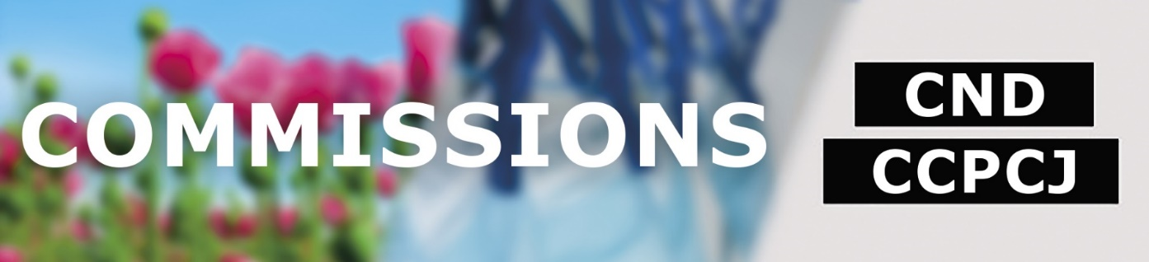

ACCESSIBILITY GUIDE

In line with the United Nations Disability Inclusion Strategy, the Secretariat to the Governing Bodies has compiled the following information in an effort to increase the accessibility of its meetings and conferences.
Contents
1. Registration 1
2. Accessibility Support Person and Support Animals 2
a) Accessibility Support Person 2
b) Support Animals 3
3. Pick-up of badges 3
4. Getting to the United Nations Office in Vienna (Vienna International Centre – VIC) 3
a) By Underground/Subway 3
b) By bus 4
c) By car 4
5. The Vienna International Centre 4
a) M-Building 4
b) C-Building 5
c) Accessible Washrooms 6
6. Accessibility needs 7
7. Accessibility resources for Vienna 7

Registration
In order to register, participants need to fill in the accessible registration form and send it to unodc-sgb@unodc.org. The form must be accompanied by
- For Member States: a note verbale from the Permanent Mission
- For IGOs: official letterhead signed by head of organization
- For NGOs: official letterhead signed by head of organization
- For UNODC staff without VIC grounds pass: official communication by head of department
The participants nominated are registered in the system and will receive an automated message to the email address provided. Participants are provided in the email with a link to upload their photo. Once the photo is uploaded, the access badge will be pre-printed, ready for collection on arrival at the VIC.
The upload portal might not be entirely accessible for users with a visual impairment. However, if no photo is uploaded, the photo can be taken at the pass office and the badge will only be printed thereafter; waiting times are to be considered.
Pick-up time for badges usually starts Friday afternoon, before the session, at a dedicated desk at Gate 1 and continues on Monday morning of the session. From Monday of the session lunchtime to Friday of the session badges can be picked up at Pass Office. The Pass Office is open between 8 a.m. and 4 p.m., Monday through Friday.
More information on the registration process is provided on the dedicated registration website of the Vienna-based Commissions.

Accessibility Support Person and Support Animals

Accessibility Support Person
A registered participant may be accompanied by an accessibility support person. To register a support person, please send an email to unodc-sgb@un.org, including the following information:
- Name of the conference participant
- Name of the support person
- Email address of the support person
If the conference participant is eligible for travel support and needs to be accompanied by an accessibility support person during the travel, the travel expenses of the accessibility support person is also covered, if approved by the medical service of the United Nations Headquarter in New York. Kindly reach out to the Secretariat (unodc-sgb@un.org) for further instructions.

Support Animals
Support animals have to be registered with security in advance. Kindly reach out to the Secretariat (unodc-sgb@un.org) at least two weeks before the conference.
Further, if you are not residing in Austria, please check the animal entry requirements on the website of the Austrian Ministry for Social Affairs.

Pick-up of badges
All participants, as well as support persons must bring their passport or national identification card and their e-mail notification with them to the Vienna International Centre, Gate 1 in order to obtain their badge. Gate 1 can be accessed from street level via stairs, as well as a ramp. The registration counter is located immediately after the security check.

Getting to the United Nations Office in Vienna (Vienna International Centre – VIC)
The VIC is located in Vienna's Donaustadt area across the Danube, just seven minutes from the city centre by U-Bahn.
The street address is Wagramer Strasse 5, 1220 Vienna, Austria, with the Visitors Entrance located right next to the "Kaisermühlen/Vienna International Centre" U-Bahn stop.
We recommend the use of public transportation. Access to all subway stations and 95% of the tram and bus stops in Vienna is accessible. The Wiener Linien provide up to date information on the accessibility in German on their website.

By Underground/Subway
From Vienna city centre, take the red U1 “U-Bahn” underground/subway line in the direction Leopoldau. Exit the U-Bahn at the stop "Kaisermühlen/Vienna International Centre". The VIC main entrance (Gate 1) is located directly at the exit at the front of the train. An accessible exit is located at the back-end of the train. Follow the signs for “Donau-City-Straße” and take the elevator downstairs. After exiting the station, turn left and take the path alongside the station building.

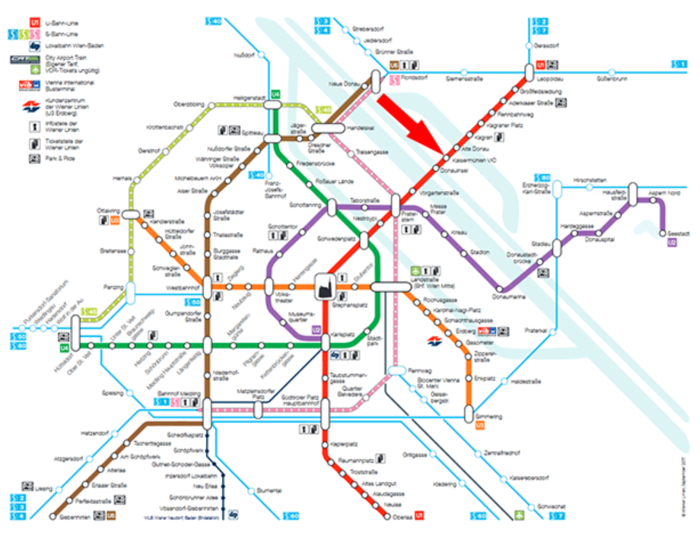

By bus
Buses may stop in the side street of Wagramer Straße 5.

By car
Limited private car parking is available for a fee at the Austria Centre.
Member States may request entry of additional cars to the VIC for the duration of the conference. Requests for temporary driver passes and temporary parking permits shall be submitted via a note verbal to the Garage Administration (vicgarageadministration@un.org) with a copy to the conference organizer (unodc-sgb@un.org). A limited number of accessible parking spots are available upon request. From the garage, the C-building can be reached via elevator. Follow the signs, pass the freight elevator until you reach the personal elevators.

The Vienna International Centre

M-Building
Most meetings and conferences take place in the M-building.
The shortest way to get to the M-building is via the B-building. Keep left after entering through Gate 1 onto the plaza, and use the first revolving doors on your left to enter the B-building. In the B-building turn right towards the A-building. The M-building will be on your left side.
The M-building is also accessible via the C-building. To access the C-building cross the square after entering through Gate 1. There is a ramp leading up to the entrance and an automatic sliding door. In the C-building turn left and follow the hallway through the A-building towards the B-building. The M-building is on the right side between the A- and the B-building.
The M-building has elevators granting access to all levels. The main conference rooms are located on the first floor.

C-Building
Smaller meetings are held in the C-building. To access the C-building cross the square after entering through Gate 1. There is a ramp leading up to the entrance and an automatic sliding door. Elevators are located in each hallway leading to a neighbouring building.
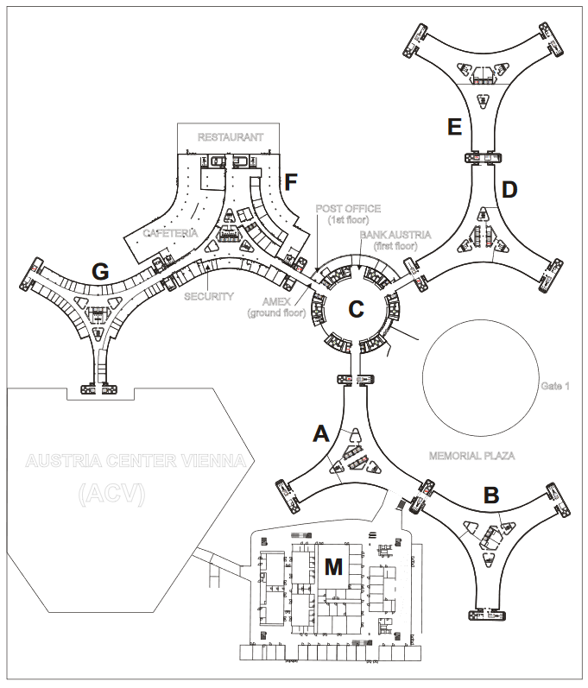

Accessible Washrooms
Building | Floor | Room number | Type
A | 05 | A05ST5 | Unisex
A | 26 | A26ST5 | Women
B | 07 | B07ST2L1A | Unisex
C | 0E | C0ETK6L | Women
C | 02 | C02TK5L | Women
C | 02 | C02TK1L | Men
C | 04 | C04TK5L | Women
C | 04 | C04TK1L | Men
C | 07 | C07TK5L | Women
C | 07 | C07TK1L | Men
E | 12 | E12ST6 | Unisex
E | 13 | E13ST6 | Unisex
F | 0E | F0EL35/1 | Unisex
F | 01 | F01ZKL1 | Women
F | 06 | F01ZKL | Men
F | 07 | F0761 | Unisex
F | 10 | F10ZKL1 | Unisex
G | 01 | G01ZKL2 | Unisex
G | 06 | G06ZKL | Unisex
M | 0E | M0E45L1 | Women
M | 0E | MOE45L | Men
M | 01 | M0165L1 | Women
M | 01 | M0165L | Men
M | 01 | M0154L1 | Women
M | 01 | M0154L | Men
M | 02 | M0265L1 | Men
M | 02 | M0265L | Women
M | 03 | M0366L | Women
M | 03 | M0366L1 | Men
Gate 1 | 0E | CP105L1 | Unisex

Accessibility needs
Please contact the Secretariat regarding all accessibility needs (unodc-sgb@un.org). Within the existing resources, we will make every effort to accommodate the requests. Possible support includes hearing loops, individual display screens, footstools, lectern risers and ramps to the podium.

Accessibility resources for Vienna
The website of the City of Vienna on accessibility compiles information on the accessibility of transport, accommodation and sight-seeing options.

