THE JOINT GLOBAL PROGRAM (GLOK67): ACCESS TO CONTROLLED DRUGS FOR MEDICAL PURPOSES, WHILE PREVENTING DIVERSION AND ABUSE

The Joint Global Program (GLOK67) is a partnership between the United Nations Office on Drugs and Crime (UNODC), World Health Organization (WHO) and the Union for International Cancer Control (UICC) with the overall objective of leading a coordinated worldwide response to improving access to controlled drugs for medical purposes, while controlling for abuse and diversion, therefore increasing the number of patients globally receiving appropriate treatment for conditions requiring the use of such medication. Given that around 5.5 billion people still have limited or no access to medicines containing narcotic drugs, such as codeine or morphine, leaving 75 per cent of the world population without access to proper pain relief treatment.

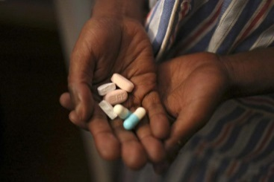

“Of all the forms of inequality, injustice in health care is the most shocking and inhumane.” (Martin Luther King, Jr.)

Approximately 92 per cent of morphine used worldwide is consumed in countries in which only 17 per cent of the world population lives: primarily in the United States of America, Canada, Western Europe, Australia and New Zealand. Inadequate awareness and insufficient access to internationally controlled substances seems to be the result of limited training and awareness of health-care professionals, policymakers and the general public (reflected in underuse, fear and overregulation), problems in sourcing, limited resources and inadequate infrastructure. Ensuring access does not mean an increase or result automatically in abuse and diversion, but it is necessary to maintain a balance between control on the one hand, and availability and accessibility on the other hand.

Too many people still suffer or die in pain or do not have access to proper pain relief treatment and to the medications they need. Unnecessary suffering resulting from a lack of appropriate medication due to inaction and excessive administrative requirements is a situation that shames us all.

The pilot programs, currently funded by Australia, on increasing access to controlled substances in Ghana, and more recently in Timor-Leste, have shown that it is possible to overcome the complex set of barriers to accessing controlled drugs.

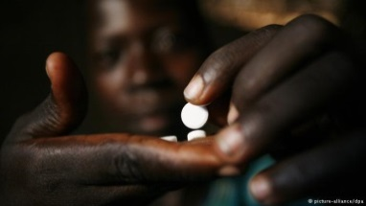

Ghana

Initially, Ghana had little infrastructure, personnel and know-how in place to increase the availability of pain relief and palliative care services in a sustainable manner. Yet this country was and continues to be in urgent need of controlled medicines and pain relief treatment. It should be recognized that the use of such substances for medical and scientific purposes are indispensable and hence their availability for such purposes should not be unduly restricted.

Countries report consumption of the following controlled medicines to the International Narcotics Control Board (INCB), in milligrams per capita and morphine equivalence:
- Fentanyl
- Hydromorphone
- Methadone
- Morphine
- Oxycodone
- Pethidine

As illustrated in the graphic below for Ghana, the consumption per capita shows a highly irregular pattern of consumption, or even the absence of consumption of some substances. The graphic reflects on the one hand the imbalance in the availability of opioids and on the other hand a lack of accurate data regarding the consumption of such substances both quantitative and qualitative.

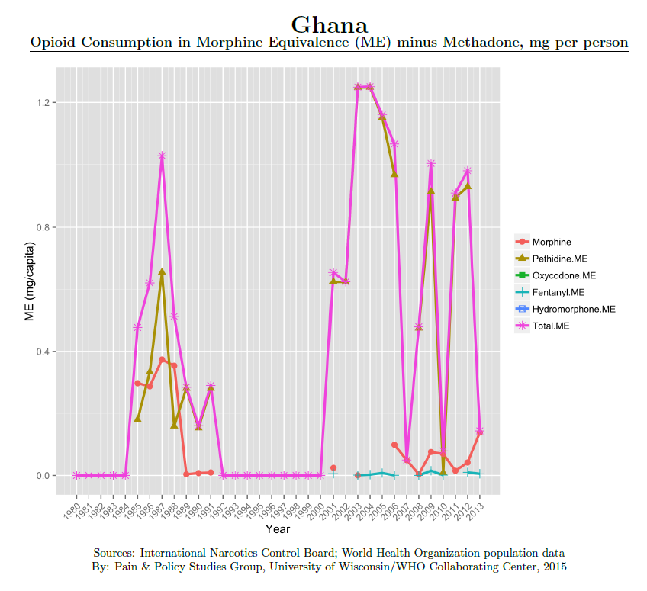
Ideally, there should be a balance between the availability of opioid analgesics for medical use in pain relief and the prevention of diversion and abuse of opioids. Reality, however, draws a different picture in Ghana: there is a huge discrepancy as the legitimate medical use is unreasonable restricted leaving patients in pain.

However, the Ghana Health Service (GHS) has demonstrated political commitment with a robust national cancer plan (National Strategy for Cancer Control in Ghana), which prioritises palliative care as core area for action. The objectives of the plan are to:
- reduce the incidence and mortality of cancer by 30 per cent through primary prevention, effective screening and early detection;
- to improve effective diagnosis and treatment of cancer by 30 per cent through evidence based cost effective interventions to reduce morbidity and mortality and to improve the quality of life for those with cancer and their family by 40 per cent through support, rehabilitation and palliative care;
- to improve the service delivery across the continuum of cancer control through effective planning and co-ordinated linked to improved resources;
- and to document 50 per cent of all cancer cases and establish a cancer registry to form the basis of delivering cost effective interventions, for research and surveillance.

In addition, a complimentary component of the Joint Global Program is the Global Access to Pain Relief Initiative (GAPRI) which is partly embedded in the National Comprehensive Cancer Plan of Ghana and this holistic palliative care plan is implemented throughout Ghana. It aims to improve palliative care including pain relief where it already exists in fledgling form and the extension of palliative care including pain relief beyond the major teaching hospitals into all communities in Ghana.

Simultaneously, the Global Opioid Policy Initiative (GOPI), aims to evaluate the availability and accessibility of opioids for the management of cancer pain and identifies a range of barriers that limit pain relief in Ghana. They have identified barriers such as special authorization is required for opioid access by outpatients, inpatients or in hospice. Second, any pharmacy can dispense opioids, but patient access to a dispensing pharmacy is deemed “occasional.” Third, pharmacists cannot accept emergency prescriptions or correct technical errors in prescriptions. Fourth, drug laws contain negative language but driving is not unreasonably restricted. Lastly, Ghana has a 2-day maximum prescription of opioids. Given that, Ghana’s 2-day limit is the most restrictive of the 25 African countries surveyed (many African countries allow 30 days on a prescription).

As part of this pilot program, Ghana has initiated changes to their policies related to prescriptions. In addition, they have identified a group of key stakeholders who are actively continuing to focus attention on this issue. The key stakeholders were instrumental in identifying the need to bring change to the structured higher education preparation of physicians and other healthcare experts, to include accurate information about the use of controlled medicines to relieve pain, manage pain over time and even to practice palliative care measures. This has been operationalized as a set of cascading training sessions that will ultimately include all levels of healthcare professional from the specialist in an urban hospital to a rural community health worker.

Additionally, four physicians were selected to participate in a three week, intensive fellowship program. Through their participation, they have expanded their knowledge and leadership skills to sustain a more impactful approach to pain, pain management and palliative care in Ghana.

Special thanks go to the Commonwealth of Australia for their continued support and commitment to ending the suffering of patients around the world.

