THE JOINT GLOBAL PROGRAM (GLOK67): ACCESS TO CONTROLLED DRUGS FOR MEDICAL PURPOSES, WHILE PREVENTING DIVERSION AND ABUSE

The Joint Global Program (GLOK67) is a partnership between the United Nations Office on Drugs and Crime (UNODC), World Health Organization (WHO) and the Union for International Cancer Control (UICC) with the overall objective of leading a coordinated worldwide response to improving access to controlled drugs for medical purposes, while controlling for abuse and diversion, therefore increasing the number of patients globally receiving appropriate treatment for conditions requiring the use of such medication. Given that around 5.5 billion people still have limited or no access to medicines containing narcotic drugs, such as codeine or morphine, leaving 75 per cent of the world population without access to proper pain relief treatment.

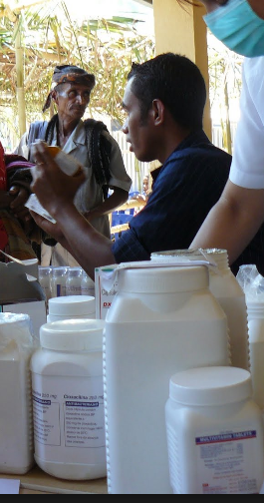

“Of all the forms of inequality, injustice in health care is the most shocking and inhumane.” (Martin Luther King, Jr.)

Approximately 92 per cent of morphine used worldwide is consumed in countries in which only 17 per cent of the world population lives: primarily in the United States of America, Canada, Western Europe, Australia and New Zealand. Inadequate awareness and insufficient access to internationally controlled substances seems to be the result of limited training and awareness of health-care professionals, policymakers and the general public (reflected in underuse, fear and overregulation), problems in sourcing, limited resources and inadequate infrastructure. Ensuring access does not mean an increase or result automatically in abuse and diversion, but it is necessary to maintain a balance between control on the one hand, and availability and accessibility on the other hand.

Too many people still suffer or die in pain or do not have access to proper pain relief treatment and to the medications they need. Unnecessary suffering resulting from a lack of appropriate medication due to inaction and excessive administrative requirements is a situation that shames us all.

The pilot programs, currently funded by Australia, on increasing access to controlled substances in Ghana, and more recently in Timor-Leste, have shown that it is possible to overcome the complex set of barriers to accessing controlled drugs.

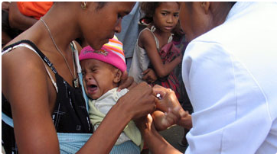

Timor-Leste

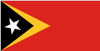

The Joint Global Program has begun the initial phase of work in Timor-Leste. Timor-Leste, which is also known as East Timor or the Democratic Republic of Timor-Leste is a relatively new country, gaining independence in 2002. While Timor faces many challenges such as poverty, poor infrastructure and issues related to literacy, they have two documents that serve as a foundation for the work in the area of increasing access to controlled drugs for medical purposes. Although the Strategic Development Plan for Timor-Leste and the National Health Sector Strategic Plan do not have a strong focus on this area, they do delineate health strategies from 2011 through 2030. It is upon these key documents that the Joint Global Program hopes to build a sustainable intervention.

There are a number of challenges in implementing healthcare in Timor, but the government is committed to making sure that all Timorese people have access to affordable healthcare through integrated health services in the community (SISCa). The six areas of focus include:
- Population registration
- Nutrition assistance
- Maternal and child health
- Personal hygiene and sanitation
- Primary health services
- Health education

The Ministry of Health, working together with communities, promotes SISCa’s activities with a principle of “From, With and To the Community”, which signifies that it is the community members who conduct the activities, mobilize people of all ages, and work side by side to give assistance, protect and improve the state of community health in the country.

The focus of SISCa is health promotion and health prevention, implementing very basic, simple and inexpensive activities that can be done in every home, workplace and community. People often put themselves in difficult situations just due to a lack of awareness and knowledge about how to live a healthy life. The Ministry of Health calls upon all the international and local NGOs who are implementing their own activities in health sector in all districts, to cooperate through the service system organized by Ministry of Health, especially through SISCa.

With a focus on building knowledge and capacity, the government leaders believe that Family Health Promoters (PSF) can help communities to become healthier, reduce the morbidity and mortality rates for children and pregnant mothers, increase immunization coverage, and reduce communicable diseases such as TB, Malaria, HIV/AIDS and other non-communicable diseases problems.

Overall, healthcare is organized into three levels:

- Primary care with 67 community health centres. Health centres typically have 2-4 doctors, 5-6 nurses, 3-4 midwives, a pharmacist, a laboratory technician and health information analyst. In addition, there are 216 health posts and mobile posts that travel between villages. Each post is staffed with 1-2 nurses and a midwife.
- Secondary care is provided in 5 district referral hospitals.
- Tertiary care is provided in one hospital in Dili, covering more complex health issues. Note that medical evacuation is a commonly selected option for complex surgery or major illness.

Timor-Leste faces common challenges that many developing countries face when implementing health services, including but not limited to lack of education and training of current staff, lack of facilities and equipment to meet the needs of patients, inadequate medical record systems, limited number of specialists, limited access to services and social norms that do not support regular prevention or treatment of medical conditions.

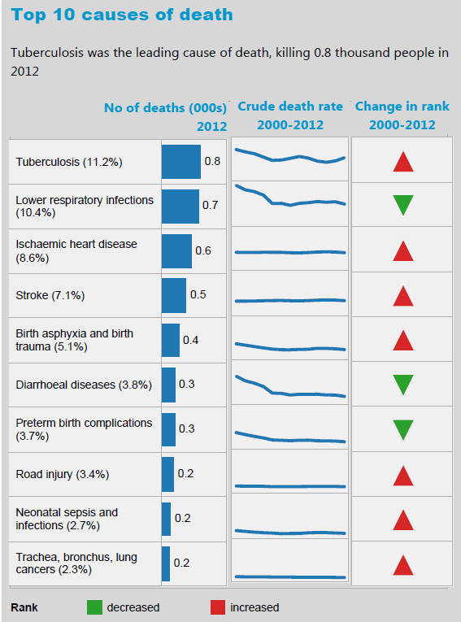

Currently, there is no available data demonstrating the consumption of controlled medicines, such as morphine, pethidine and oxycodone in Timor-Leste. The work of the Joint Global Program will include the following activities to begin in March 2016:
- Identify key stakeholders and convene a stakeholders meeting
- Hold two day awareness raising session for health practitioners and policy makers
- Identify gaps and barriers to access
- Identify areas within the SISCa health system approach to integrate palliative care
- Create a national strategic approach in line with the National Health Sector Strategic Plan
- Comply with the requirements of the International Narcotics Control Board.

Special thanks go to the Commonwealth of Australia for their continued support and commitment to ending the suffering of patients around the world.

