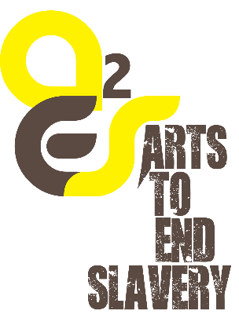
Telling their Stories
“Someone is willing to listen to me. Someone actually thinks that my opinion counts. My story is important." Human trafficking survivor
Awareness Against Human Trafficking (HAART) – a Nairobi based NGO – launched a new and exciting project- Arts to End Slavery in May 2015, the project is now in its second year. The purpose of the project is to create awareness on the issue of human trafficking through art. Human trafficking can be defined as the recruitment of people by deception, coercion or force for the purpose of exploitation including forced labor and sex work.
In commemoration of the 2016 World Day against Trafficking in Persons, UNODC seeks to promote a better understanding and a greater engagement throughout the international community on the vulnerabilities that lie behind every case of human trafficking and the exploitation suffered by every victim of this crime. Vulnerability, in all its different forms, is central to how trafficking is understood and to how it can be tackled. The 2016 theme, ‘Vulnerabilities to trafficking in persons’ is aligned to the large mixed migration movements being experienced globally, from the impact of conflict and natural disasters, and the resulting multiple vulnerabilities to human trafficking . The theme is also a call to reflect upon the fact that a majority of victims will never be identified or receive the much needed assistance required to deal with their ordeal.
Arts to End Slavery (A2ES) is a moving art exhibition that explores the multifaceted nature of human trafficking. In “Telling their stories”, artists open up this dialogue by imagining and embodying the narrations of those trafficked. The artists featured in this exhibition use painting, photography, installation, film and video to show different perspectives and forms in which human trafficking takes place and how anyone, no matter the gender, color or age can be trafficked. While some artists use the imagery of the body to explore notions of commodification and displacement, others capture the emotional cost as experienced by those trafficked referring to what it means to exist between hope and fear. The exhibition suggests the need to dismantle all forms of oppression, and offers a rare opportunity to conceive potential policy actions in solidarity with those undermined. It is an occasion to do more, to take us further, and to enable us to imagine and act in ways that lead to radical actions.
“Telling their stories” will be on display with the support of UNODC at the UNON main lobby from 15-19 August, 2016. A launch will be held on 16th August 2016, from 12.30-1pm with brief remarks from the UNODC, Regional Representative, Mr. Jose Vila Del Castillo and Ms. Sophie Otiende, Project Consultant, HAART.

