June 2015
ICCWC Toolkit Report Presentation in Botswana

June 16, Gaborone. United Nations Office on Drugs and Crime (UNODC) presented to the Government of Botswana the findings of the analytical report on wildlife and forest crime in the country.
The report is based on the results of the fact-finding mission undertaken by UNODC international experts in cooperation with the government of Botswana from 18 January to 1 February 2015 using the ICCWC Wildlife and Forest Crime Analytic Toolkit. The report was developed in consultation with all UNODC partners of ICCWC- the International Consortium on Combating Wildlife Crime (CITES Secretariat, INTERPOL, World Bank, World Customs Organization) and was financially supported by the Bureau of International Narcotics and Law Enforcement Affairs (INL) of the US Department of State.
The report provides a comprehensive, evidence-based analysis of all relevant entities, the threats, and the national response to wildlife and forest crime in Botswana and includes recommendations for short-, medium- and long-term actions in the areas of legislation, law enforcement, prosecutorial and judicial capacities, data gathering and analysis, and prevention.
In the process of the development of the report, following entities were consulted:
- Attorney General’s Chambers
- Botswana Defence Force
- Botswana Police Service
- Botswana Unified Revenue Service
- Civil Aviation Authority of Botswana
- Department of Forestry and Range Resources
- Department of Wildlife and National Parks
- Directorate on Corruption and Economic Crime
- Directorate of Intelligence and Security
- Directorate of Public Prosecutions
- Financial Intelligence Agency
- Forensic Science Services (BPS)
- Department of Justice
- Prison Service
- Several NGOs
UNODC would like to express special thanks to the international experts Mr. John Sellar and Mr.Brian Taylor who conducted the assessment, and to Dr.Cyril Taolo, Deputy Director and Chief Wildlife Officer, Botswana Department of Wildlife and National Parks (DWNP), for coordinating the in-country mission and the release of the report and to Mr. Lewis Mokowe, Senior Wildlife Warden and Deputy Head, Investigation Unit of DWNP for his support throughout the mission.
UNODC and other partners of ICCWC stand ready to support the Government of Botswana in the implementation of the recommendations aimed at strengthening the national response to wildlife and forest crime and the increasing pressure from the organized criminal networks which are operating throughout East and Southern Africa.
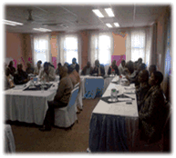 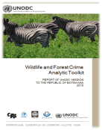 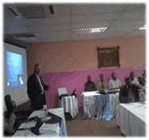 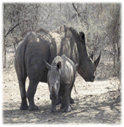

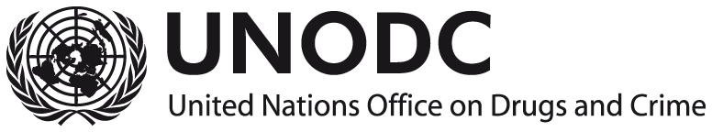
Vienna International Centre
Global Programme for Combating Wildlife and Forest Crime
Sustainable Livelihoods Unit
P.O. Box 500, 1400 Vienna, Austria
Email: WLFC@unodc.org, Tel:(+43-1) 26060-83040, skype / unodc.slu

