REGISTRATION FORM CND/CCPCJ
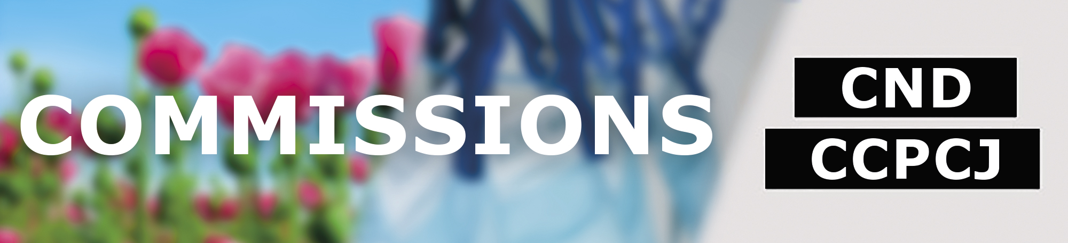
Please see the guidelines on registration: http://www.unodc.org/unodc/en/commissions/registration.html
Please email to unodc-sgb@un.org, together with Note Verbale / official letter
If any delegation member has specific accessibility needs (e.g. wheelchair access, service animal, hearing loops), please contact unodc-sgb@un.org

Submitted by (please select one)
☐ Member State
☐ IGO
☐ UN entity
☐ NGO in consultative status with ECOSOC (Note: up to 10 participants can be registered)
☐ Public

Title of the Meeting (please fill out)
Commission, session:
Date:

Participants for registration
# | FIRST NAME / FAMILY NAME | TITLE/FUNCTION | WORKPLACE/ORGANIZATION | E-MAIL ADDRESS
1
2
3
4
5
6
7
8
9
10

